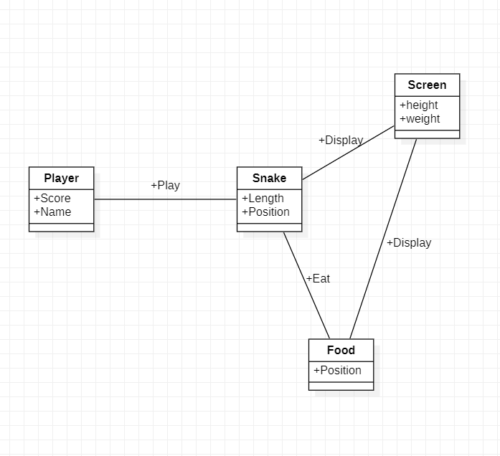

UML on the snake game:

In order to represent the different game elements in the snake game, we choose to split the information into four objects creating four categories: Food, Player, Snake and Screen.

In the game the player object holds information about the user and will update in real time relatively with what’s happening in the game. As the player control the snake, there is a need to store information about the snake current length and position for it to be updated on the screen. Finally, the snake is able to interact with the food in order to gain in length, thus resulting in the player increasing his score because the goal of the game is to eat as many food as possible without losing.